Unjamming the Global & Quantum Payout Base
This Guide will lead you through the process of unjamming a Global or Quantum Coin changer payout base.
You will recognise a payout jam when either tubes A & B or tubes C & D will not payout when the inventory buttons are pushed. You may also hear the payout motors squealing as they try to work against the jam.
Do not attempt to clear a jammed coin with screwdriver as this will cause further damaged to the payout base and further jams.
To unjam the payout, the payout sweeper and coin must be removed, the driver gears returned to home position and the sweepers replaced.
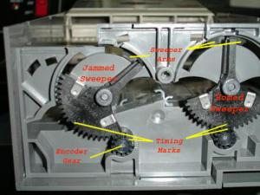
To achieve this follow this procedure.
- Remove the three payout base screws and remove the lower payout base cover.
- Remove the payout sweepers and any jammed coins. When removing the jammed sweeper pull it out with your finger at the gear teeth, whilst pushing the upper part in toward the tubes , so as to ensure the sweeper arms don't break when the sweeper is removed
. 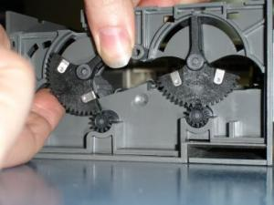

- Whilst the sweepers are removed, power-up the changer so as the driver gears re-align.
- Refit the sweepers ensuring that the timing marks on the sweeper and driver gear line-up, also ensure the wire circle on the top of the sweeper lines up with the sweeper's hole.
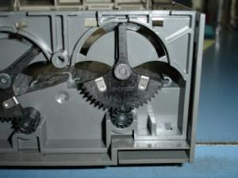
- Refit the lower payout base, ensuring the coin clearing arm is in the proper position to allow the base to the replaced easily.
- Refit the payout screws, gently so as to not damage the plastic housing, do not over tighten the screws, and ensure that all coin tubes are seated correctly.
Do not use any form of lubrication (eg. WD40, grease) for the payout as the will clog the sweepers and cause further jams.
Test the coin payout from all tubes, if jamming continues send coin changer to be serviced.

