Unblocking The Sort Sensor In The Guardian 6000
The Guardian Sort sensor is located beneath the sort door. The sort door is opened by pushing
the sort door latch to the left, this allows the sort door to open outwards.
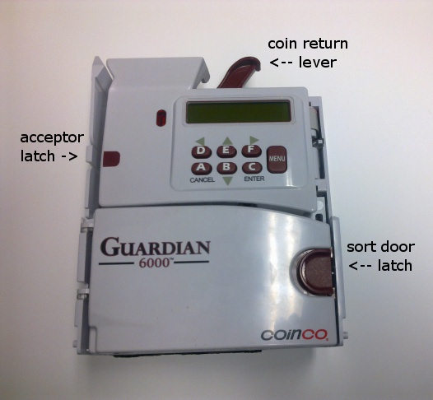
The sort sensor is an optical sensor on the right side of the acceptor, an unblocked sensor
will display a red light. A blocked sort sensor is generally caused by a coin jammed in this
area.
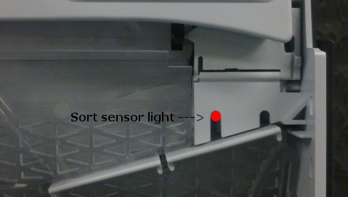
Follow the procedure below to remove any coins jammed in this area:
Ensure power is OFF when removing the the acceptor head from the coin mech, the acceptor head
can be removed from the coin mech by pressing the latch on the left of the acceptor head to the
right and then using the coin return lever to pull the acceptor head forward, this will reveal
the acceptor harness attaching it to the coin mech, unplug this harness and remove the acceptor
head from the coin mech.
With the acceptor head detached, open the sort door and remove the lower intermediate covers
that are below the coin runs. The covers are removed by unlatching them on the right side and
pulling them down.
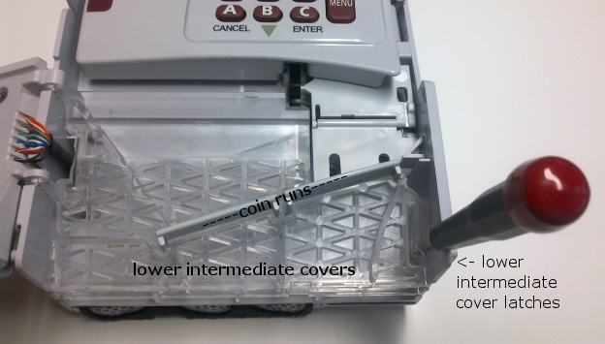
Remove the coin jam and replace the lower intermediate covers. Special care should be used to
ensure the coin stops on the back lower intermediate cover are repositioned into the holes in
the coin runs. The lower intermediate covers should click back into place.
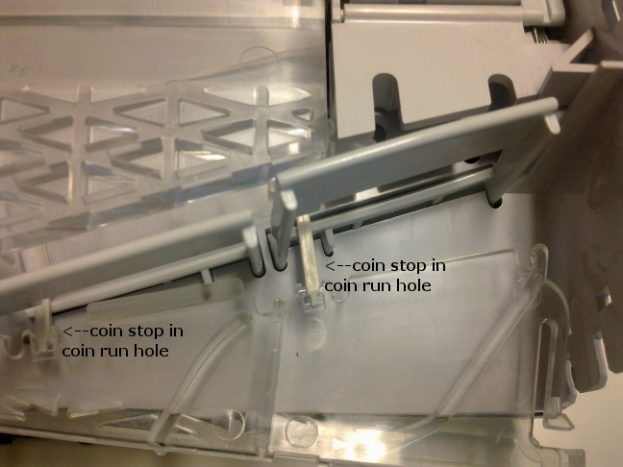
Then close the sort door, and replace the acceptor head back into the coin mech, ensure care is
taken when plugging the acceptor harness back into the connector so as to not bend any of the
connectors pins. Then power ON and test, if any problems occur, power OFF and check the pins on
the acceptor harness connector. If problems still occur return coin mech to Coinco service
centre for repair.

