

Small package 250ml Kit for Merlin 1V Vendors
Kit part No: 257018

Kit Contents: 1 x 256155 metal shim plate, 1x 815375 extruded white plastic wall
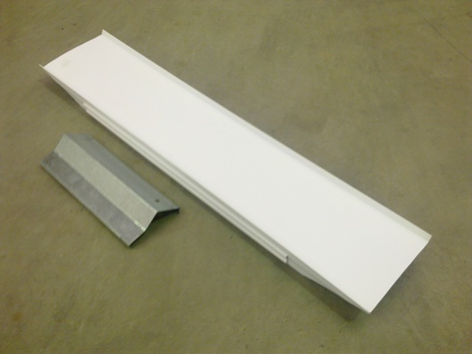
815375
256155

Fitting Instructions-
Note: Were at all possible the 250ml kit is best suited in the rear columns.
1) Installing the kit in the rear column requires the removal of the centre column divider as shown in photo 1.
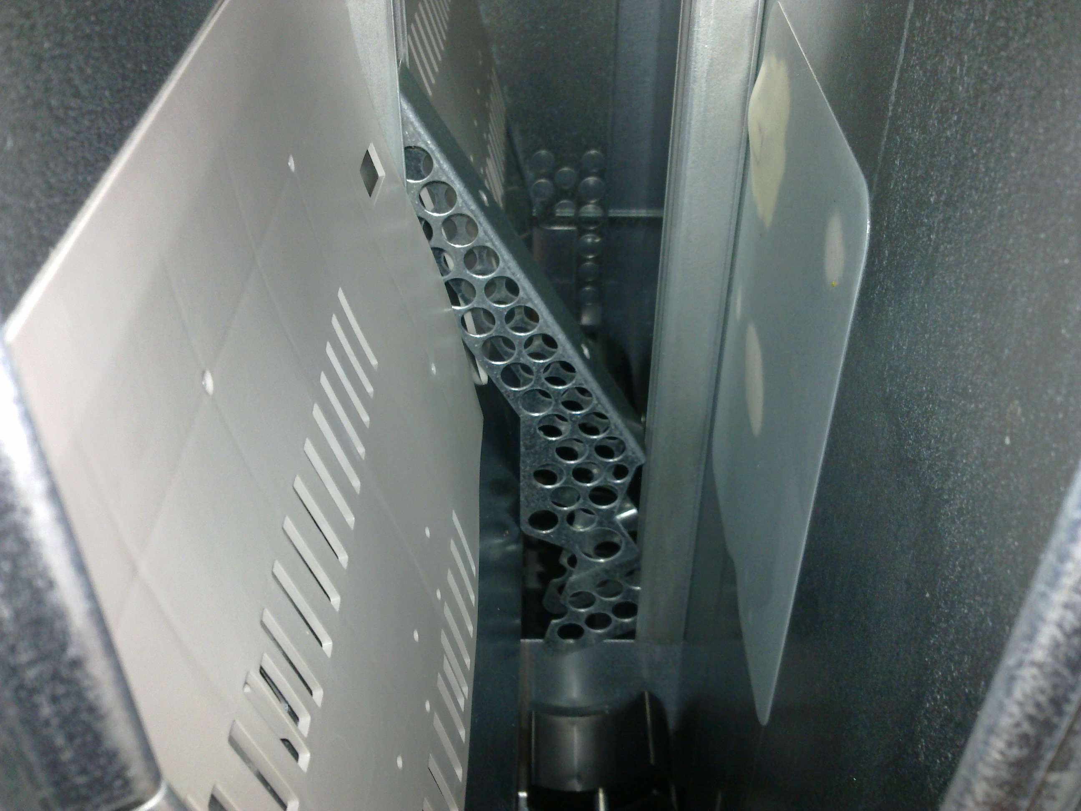
Remove
Photo 1
- The 256155 Shim Plate has 2 hooks on one edge which are used to hang the shim plate from the existing baffle plate in the rear column as per photo 2 - 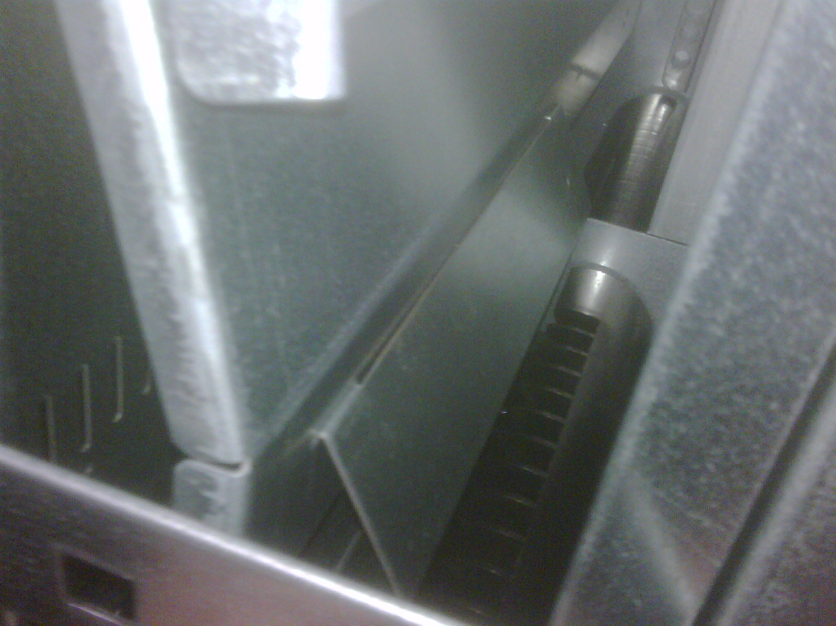
256155
Photo 2

- The extruded white plastic is fitted vertically to the centre column wall divider via the clip on one side of the component. Once installed it should resemble photo 3 -
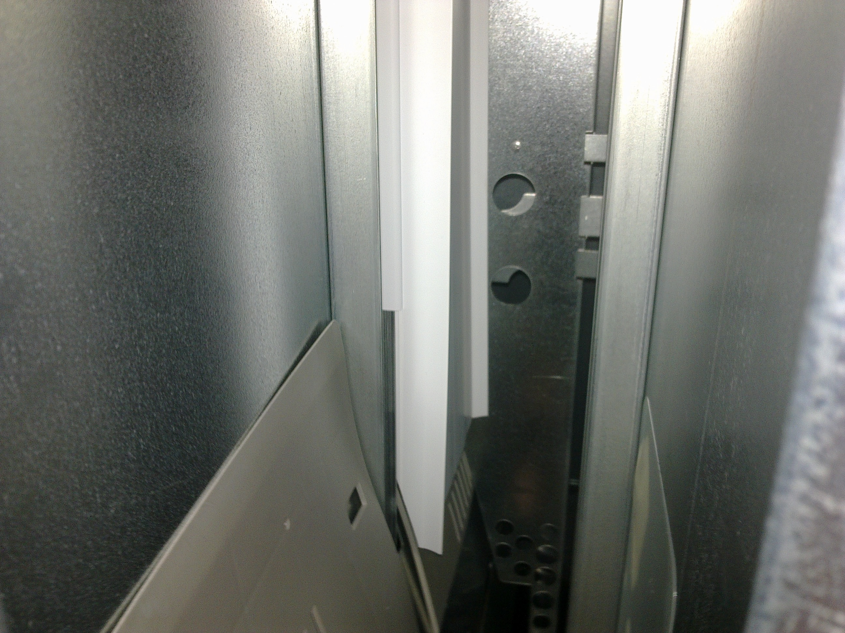
815375
Photo 3
- Once the white plastic extrusion has been fitted it is necessary to bring forward the rear retaining panel to sit flush with the rear edge of the white plastic extrusion.
- Important: Once components are fitted as above the DEPTH setting in the service menu needs to be set at “1” for that selection. This is done by going into the “Service Menu’s” by pressing the mode button on the control board. “Cash” should appear on the display and by using the number 1 selection button scroll thru to “SdEP”, press the enter button ( selection button 3) “ALL” should appear on the display, press the number 1 selection button and scroll through until the desired selection is shown e.g. S8 2. The number “1” or “2” will appear next to the selection number, pressing the enter button will cause the number “1” or “2” to flash, pressing the number 1 selection button will change the number from “1” to “2” or “2” to “1”, (1 being for single depth, 2 for double depth). Confirm the number 1 is selected and press the enter button once, the number will stop flashing, now the Depth setting has been set, press and hold the number 3 selection button to exit out of the menu.
(Note: All new Royal vendors come factory set to Double Depth “2” as the default setting.)

Installation Notes:

- The centre column divider has been removed to allow easier access to rear column. (refer photo 3).
- The kit is best suited in the rear column; access to rear column is hindered if fitted to front column.
- Depth setting for that selection must be set to “1” or the vendor will drop 2 cans (refer note 5).

For further assistance please contact:

Coin Acceptors PTY LTD/ Royal Vendors
Ph: (02) 9890 5433

